17-647 Assignment A4: Service data replication, NoSQL database, CQRS

Problem Description
In this project assignment, we will introduce additional concepts and technologies discussed in class:
- Use of a document-based NoSQL database
- CQRS design pattern
- Service Data Replication pattern

Learning Objectives
This project is designed to introduce you to core technologies and design strategies and patterns commonly used in distributed systems. These technologies and design strategies include:
- AWS services: EC2, VPC, CloudFormation (CF)
- MySQL on AWS RDS
- Load balancer and passive redundancy
- Postman (or similar API testing tool)
- Docker
- Python with Flask, Node JS and Express or other language/framework that you choose to create your services
- Service-to-service HTTP interaction
- JWT (added in A2)
- BFF pattern (added in A2)
- Single Responsibility Principle (added in A2)
- Kubernetes and EKS (added in A3)
- Kafka and publish-subscribe (added in A3)
- Circuit breaker and bulkheads (added in A3)
- CloudWatch for log consolidation and monitoring (added in A3)
- DB per microservice pattern (added in A3)
- NoSQL DB (MongoDB) (added in A4)
- Service data replication (added in A4)
- CQRS (added in A4)
- Data synchronization via a cronjob batch program, logstash, or other mechanism (added in A4)

Architecture overview
The diagram below shows the runtime architecture perspective that you should implement for this assignment. The details are in the following sections.

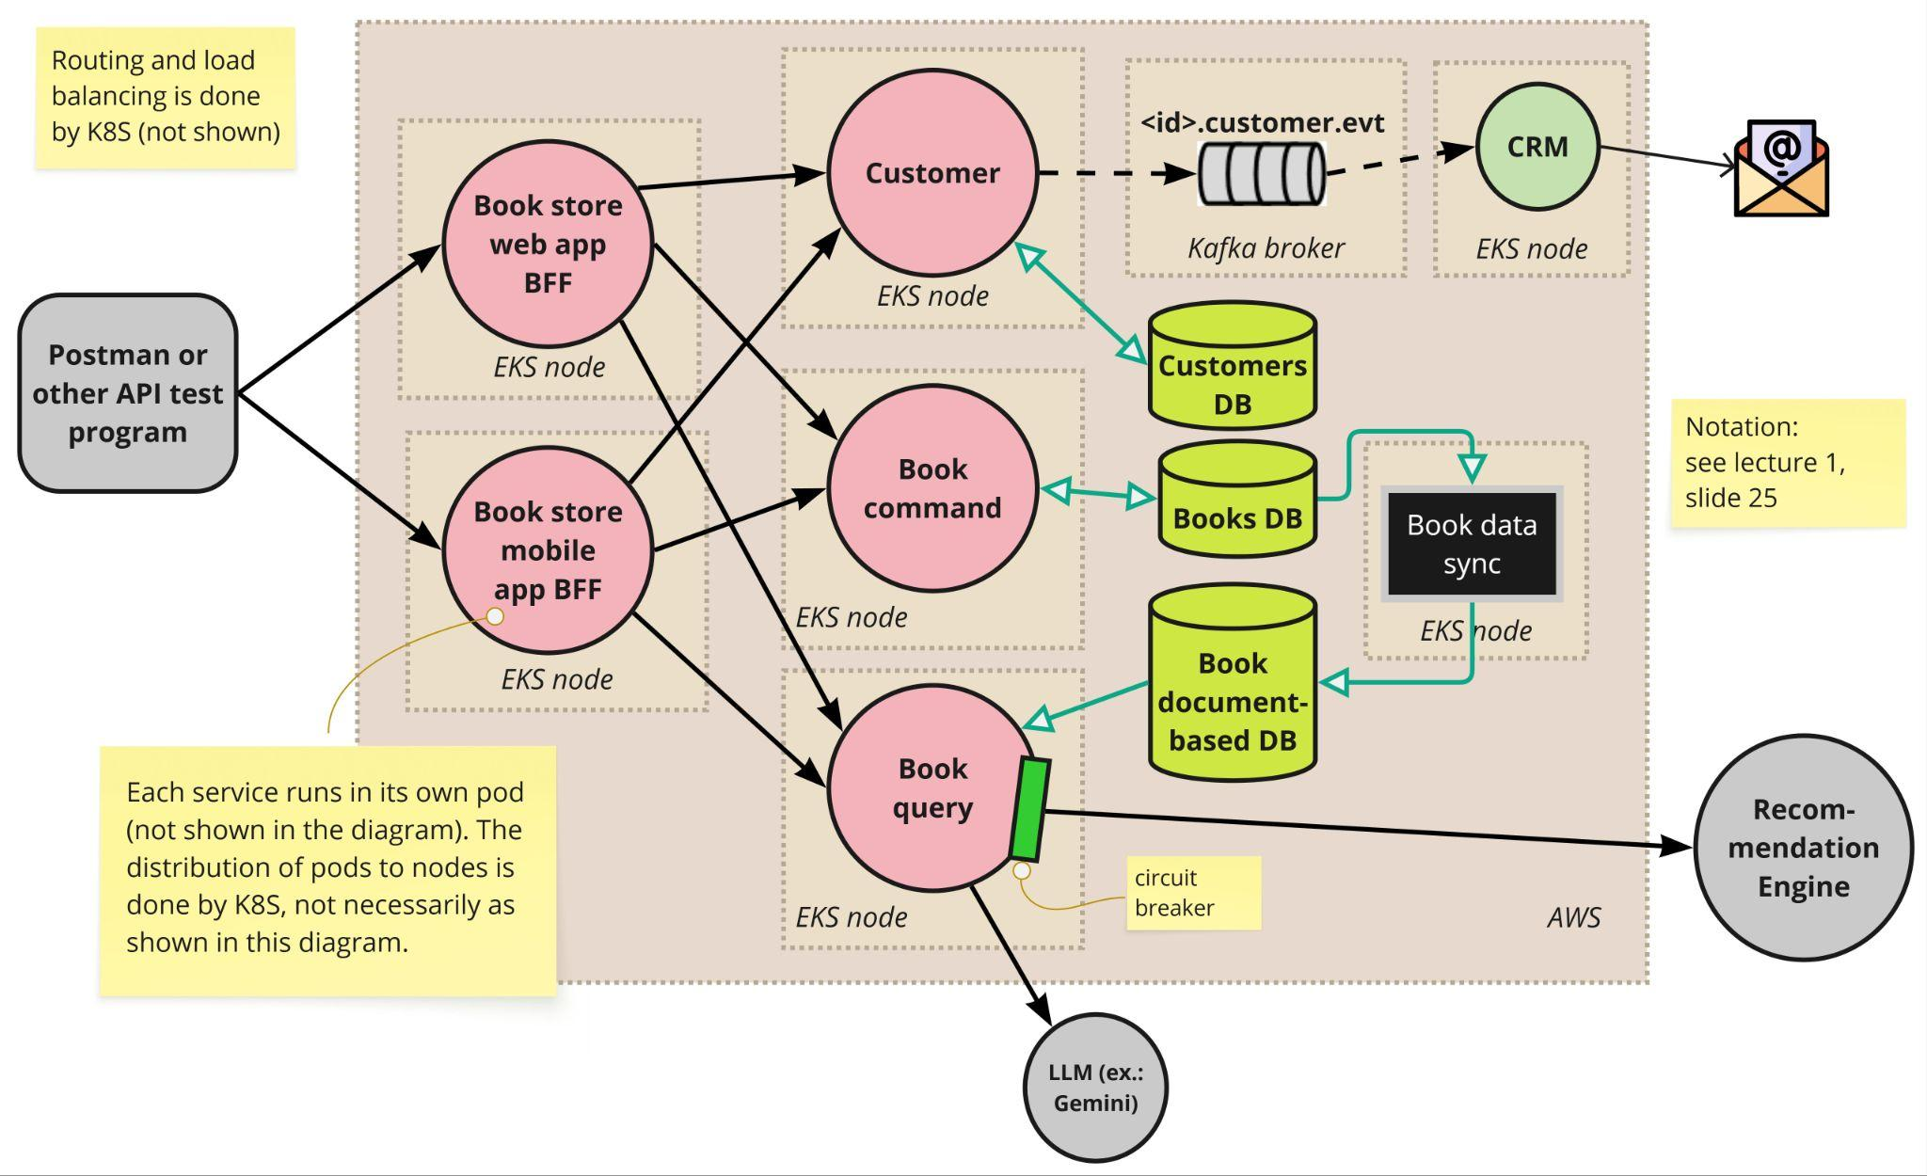

The diagram below shows the AWS deployment perspective. The diagram uses the standard AWS notation for AWS infrastructure design diagrams (the K8S and Kafka logos are not part of that).
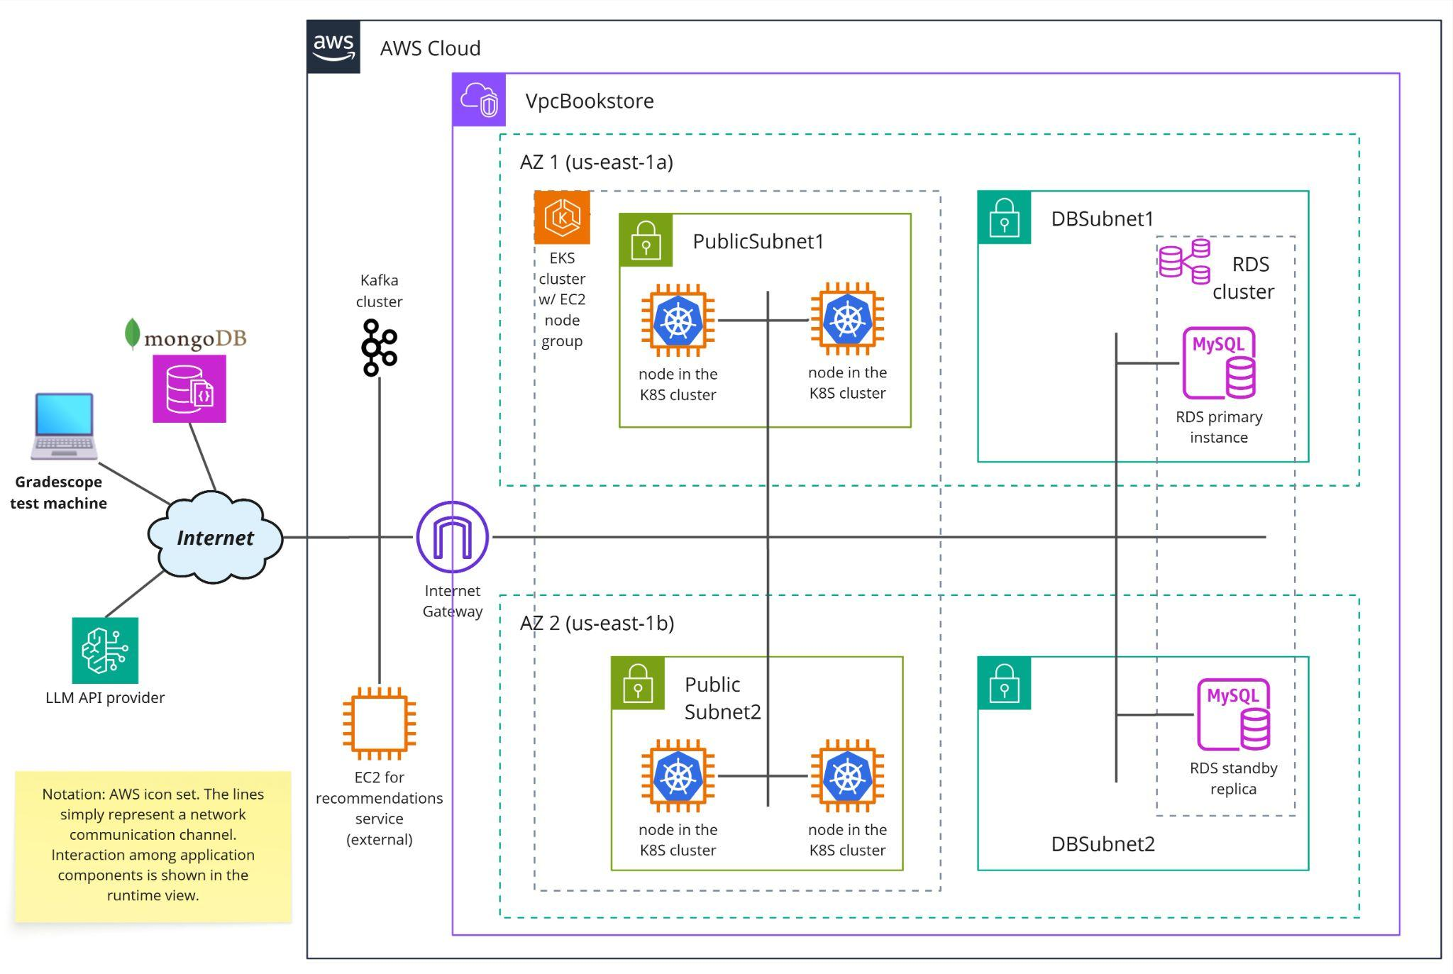

You will use the same services you created in A3 and deployed to EKS, except for: (i) Book service is split into two services; (ii) a Document-based database is used for queries; and (iii) a batch program is used for data synchronization. The details of what’s required is in the following sections.

Task 1: MongoDB database
The first requirement is to create a 2-instance DocumentDB cluster (MongoDB). You can do that using CloudFormation and creating another resource of type DBCluster. However, for the DocumentDB cluster the engine should be “docdb”.

A MongoDB was created in the cloud, so you don't need to create it on your own. We'll create user IDs to access the MongoDB on demand, just send a request via email to the instructor team (TAs and instructors) of your class.

In the MongoDB cluster, you will store book documents in a collection called “books_<andrewID>” (collection is a namespace within MongoDB where you will store documents that typically have the same or similar structure).

Task 2: CQRS
The CQRS pattern shall be applied to the Book service used in A3. The service will be split into two: Book command and Book query. The endpoints in BFF services remain unchanged, but their implementation will now call the endpoints of Book command or Book query.

Book command will offer the data changing endpoints. The URIs remain unchanged, except for the path element /cmd (this slight change in the URI will facilitate the routing on K8S):
- POST {BASEURL}/cmd/books
- PUT {BASEURL}/cmd/books/{ISBN}
The implementation of these endpoints remains unchanged, as they will still insert and update the data on RDS.

Book query will offer the GET endpoints we had in previous assignments (listed below) and a new endpoint (described further below):
- GET {BASEURL}/books/isbn/{ISBN}
- GET {BASEURL}/books/{ISBN}
- GET {BASEURL}/books/{ISBN}/related-books

The implementation of GET {BASEURL}/books/{ISBN}/related-books remains unchanged, as it will still interact with the external recommendation service as in A3.

The other two GET endpoints will retrieve the book document from MongoDB instead of reading the data from RDS, but the response message remains the same. (Your Book query microservice shall not connect to RDS.)

The Book query service shall provide a new endpoint:

Search Books by keyword endpoint
  - GET {BASEURL}/books?keyword={keyword}
  - Description: full-text search for {keyword}. This endpoint shall query the MongoDB collection looking for any book documents that contain the given keyword anywhere in the document data. For simplicity, the keyword must be a single word (characters a..z and A..Z only). For example, if the keyword is “Alice” the endpoint should return books where the word “Alice” shows up in the title, author, description, genre, or summary attributes. The text search should be case insensitive.
  - Return values:
    - 200 status code if a document was found on MongoDB. Response body example (it’s an array):
[
{
"ISBN": "978-0321815736",
"title": "Software Architecture in Practice",
"Author": "Bass, L.",
"description": "seminal book on software architecture",
"genre": "non-fiction",
"price": 59.95,
"quantity": 106,
"summary": "\"Software Architecture in Practice\" is a comprehensive guide..."
}
]
    - 204 status code if no document was found on MongoDB. The response body is empty.
    - 400 status code if the keyword is not a String of a..z and A..Z characters only.

Book command and Book query shall also provide the GET /status endpoint used for the liveness probe in the K8S deployment.

Task 3: Data synchronization
As you already realized, the MongoDB books collection is a replica of the Books table on RDS, which is the primary data store. Therefore, we need to implement a data synchronization mechanism. Requirements:
- The synchronization shall be executed minimally every N seconds, where N is configurable outside the code (details ahead).
- The synchronization shall read Book rows from the RDS table and store them as JSON documents on MongoDB.
- The structure of the JSON document with book metadata should be the same used in the REST API. Example:
{
"ISBN": "978-0321815736",
"title": "Software Architecture in Practice",
"Author": "Bass, L.",
"description": "seminal book on software architecture",
"genre": "non-fiction",
"price": 59.95,
"quantity": 106,
"summary": "\"Software Architecture in Practice\" is a comprehensive guide..."
}

The architecture diagram shows a Book data sync batch program as the component responsible for data synchronization. You have plenty of latitude as to how to implement that program. You can use any programming language, library or tool. The program should run in the EKS cluster (as shown in the diagram).

Following are some guidelines on how to create Book data sync as a simple ETL program.

- ETL programs usually make use of metadata describing when a given source record was created/updated as well as when did the ETL job executed last and what it did. The goal is to expedite execution by synchronizing only the delta between the source data store and the target data store.
- For this assignment, as a simplification, it is OK if the Book data sync program always synchronizes the entire database. In other words, for every book in RDS, you can update the corresponding document on MongoDB. The MongoDB API allows “upsert” (update+insert), that is, if the book being updated does not exist, it is inserted. Optionally, you may add a date/time column to your RDS table and keep track of data sync executions so that you only synchronize books that were inserted or updated since the last execution.
- Thus, your Book data sync program will basically:
- Read all books from RDS;
- For each book,
  - generate the corresponding JSON document;
  - update it on MongoDB

- If you create Book data sync as described above, you can deploy it as a CronJob on EKS. In that case, the K8S yaml will specify the cron scheduling, so the period “N seconds” for periodic execution is set there.
- For the sake of the autograder, please use N = 60 seconds.

You can also implement the data synchronization using libraries or tools.
- This post has a list of node.js libraries for ETL. In the JVM world, Spring Batch is a popular library used for ETL. These libraries often provide you with a nice API for the three operations the program has to perform: extracting/reading, transforming, loading/writing. In addition, they often provide a scheduling mechanism, exception handling, execution reports, etc. You should avoid using the library’s scheduling mechanism, based on the design considerations discussed further below.
- Another popular alternative is Logstash. This is a tool offered by the same company behind ElasticSearch, but it can be used to read data from MySQL and update a MongoDB collection with the MongoDB output plugin for logstash.
Design considerations for a periodic ETL batch program:
- Does the implementation allow concurrent execution (of two instances of the batch program)? If not, the period between executions should be comfortably larger than the expected execution time.
- Some implementation libraries offer a scheduling mechanism. If you use it, you can deploy your batch program as a Job instead of a CronJob. However, in that case, your Job and respective pod have to be active all time, which is more expensive in a cloud environment. A CronJob definition is better because it only opens a Job and pod when it is time to run the batch program (per the cron schedule controlled by K8S).
- Another benefit of using a CronJob is that you can specify the concurrency policy. For example, if your batch program is not idempotent, you can set concurrencyPolicy: Forbid and K8S will not open an execution if the previous one is still running.
—————
You are expected to use good programming practices with proper error handling.
You will also need to be sure to comply *exactly* with the specification provided. Any deviation will result in a failed test case even if the functionality is implemented correctly.

Technologies and Resources
In this assignment, you should also configure the AWS infrastructure and deploy your application using our Learner Lab course in the AWS Academy platform.
No new CF template is provided, as the basic infrastructure is the same used for A3.

Submission
Same as A3, except for:
- Instead of Book we have Book command and Book query, each of which requires a separate Dockerfile and K8S yml files.
- The data sync program also requires a Dockerfile and K8S yml file (kind CronJob or Job). No K8S service definition is required for the data sync program, since it’s not a service or microservice.
- The data sync program should be clearly separated (in a different subdirectory) from the microservices.

Grading
The grading for this project will be:
- The requirements were correctly implemented.
- The system is able to handle correct and invalid input and return the correct HTTP code in the response.
- The architecture of the system matches the instructions provided.

